

Game Design Document for:

Purgatory

The Ultimate Afterlife Game

“Your Fate depends on your last game!”™

All work Copyright ©2021 by Your Company Name

Table of Contents

NAME OF GAME 1
DESIGN HISTORY 4
Version 1.10 5
Version 2.00 5
GAME OVERVIEW 6
Philosophy 6
Philosophical point #1 6
Philosophical point #2 6
Philosophical point #3 6
Common Questions 6
What is the game? 6
Why create this game? 6
Where does the game take place? 6
What do I control? 6
How many characters do I control? 6
What is the main focus? 7
What’s different? 7
FEATURE SET 8
General Features 8
Multiplayer Features 8
Game play 8
THE GAME WORLD 9
Overview 9
World Feature #1 9
World Feature #2 9
Game Engine 10
Overview 10
THE WORLD LAYOUT 12
Overview 12
World Layout Detail #1 12
World Layout Detail #2 12
Card Decks 13
Overview 13
Stats 13
USER INTERFACE 14
Overview 14
User Interface Detail #1 14
User Interface Detail #2 14
SOUND EFFECTS 16
Overview 16
MULTI-PLAYER GAME 18
Overview 18
“XYZ APPENDIX” 22
“OBJECTS APPENDIX” 22
“USER INTERFACE APPENDIX” 22
“NETWORKING APPENDIX” 22
“STORY APPENDIX” 22

Design History

This is a brief explanation of the history of this document.

In this paragraph describe to the reader what you are trying to achieve with the design history. It is possible that they don’t know what this is for and you need to explain it to them.

Version 1.10

Version 1.10 includes some tuning and tweaking that I did after making my initial pass at the design. Here is what I changed.

- I rewrote the section about what systems the game runs on.
- I incorporated feedback from the team into all parts of the design however no major changes were made.
- Just keep listing your changes like this.

Version 2.00

Version 2.00 is the first version of the design where a major revision has been made now that much more is known about the game. After many hours of design, many decisions have been made. Most of these large design decisions are now reflected in this document.

Included in the changes are:

- Pairing down of the design scope. (Scope, not design)
- More detailed descriptions in many areas, specifically A, B and C.
- Story details.
- World layout and design.

Game Overview

Philosophy

Philosophical point #1

Our game is inspired by Dante's comedy, the player character has died and gone to purgatory where you will meet the gatekeeper. The gatekeeper is the card dealer in our game. The gatekeeper looks after the gate leading to either hell or heaven

Philosophical point #2

Our game only runs on Compaq computers. The reason for this is such and such. We believe the world is coming to and end anyhow so what difference does it make?

Common Questions

What is the game?

The game is a local multiplayer card game about the constant conflict between Heaven and Hell, deciding the fate of the player. The gameplay will be similar to Hearthstone and other card games.

Why create this game?

The main reason we are creating this game is to show our progress learning the program Unreal, using a blueprint. This game is also the final project/assignment for the module “Game Flow” for 1st semester,

Where does the game take place?

This game takes place in Purgatory which is where the souls of the dead go after passing away, before they are sent to a final destination whether that would be Heaven or Hell.

What do I control?

The player will get to choose which side they will fight for by picking between two decks. The first deck will have the theme of Heaven, the second will have the theme of hell. The first deck will be more control focused whereas the second deck will be more aggro focused.

How many characters do I control?

The player will control one of the decks of cards that are made of 15 up to 30 cards.

What is the main focus?

Players are sent to purgatory where they will meet the gatekeeper, he will provide 2 decks of cards for the players to choose from, they will then fight against each other to decide their fates, the winning player will go to heaven whereas the losing player will be sent to hell. The main objective of the game is to make your opponent lose all of their health.
What’s different?

Our story and aesthetic is unique compared to traditional card games.

Feature Set

General Features

2D playing board

Multiplayer Features

2 player local multiplayer
Instant gameplay

Gameplay

The player will enter the game and be given the option of choosing between 2 card decks, once they are done choosing a deck they will then be placed into the game where they will see the game board and will be given 5 starting cards, upon using a card will then draw another card. When a card dies it is placed in the graveyard.

The Game World

Overview

The game will be set in purgatory which is the space between heaven and hell.
.

World Feature #1

The board will be split in two, one side more angelic, the other more hellish. The gatekeeper will be the card dealer.

World Feature #2

Same thing here. Don’t sell too hard. These features should be awesome and be selling the game on its own.

Game Engine

Overview

We will use Unreal Engine 4.27 to render a 2D board. The board will be illuminated with a bright light while the surroundings will be dark with some bright spots representing candle flames.

The World Layout

Overview

Provide an overview here.

World Layout Detail #1

World Layout Detail #2

our board will be split into 2 sections, the player will be on the bottom of the screen no matter what deck they choose, the board will also be split atmospherically what we mean by this is one side will be heaven themed with golds and whites whereas the other will be hellish with red and dark colours

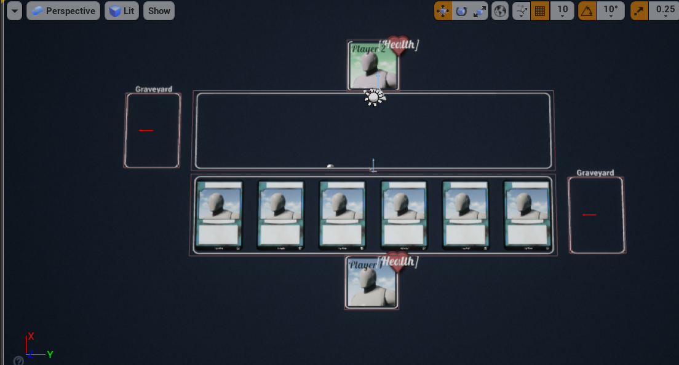
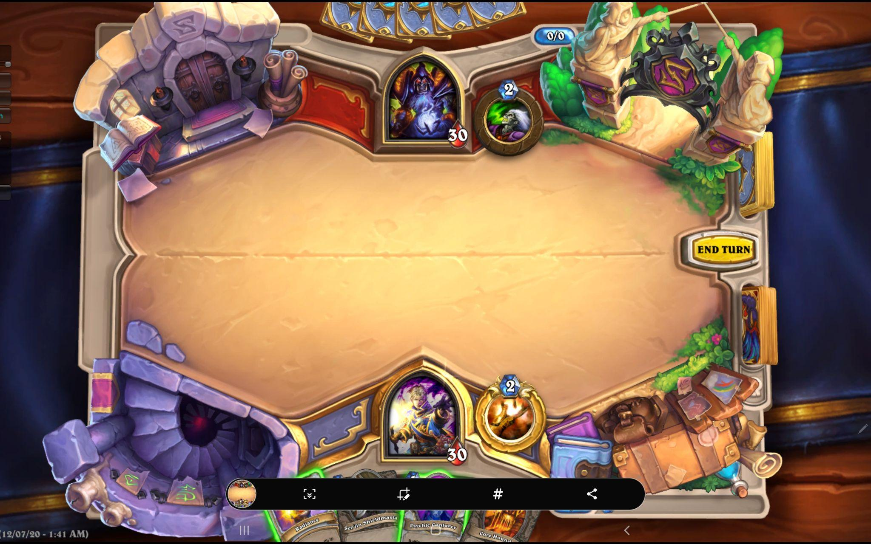

Card Decks

Overview

For the first deck (Heaven), The Paradiso (by Dante) will be represented by having different cards for the multiple spheres of Heaven while for the second deck (Hell), The Inferno (by Dante) will be represented by having different cards for the multiple circles of Hell.

Stats

1st Deck - Heaven | Stamina | Health | Attack | Abilities
Ethical Soul | 1 | 2 | 1 | Taunt
Ethical Soul | 1 | 2 | 1 | Taunt
Warriors of the Faith | 2 | 2 | 2 | Taunt
Warriors of the Faith | 2 | 2 | 2 | Taunt
Lovers | 3 | 2 | 2 | Player gains 3HP back
Lovers | 3 | 2 | 2 | Player gains 3HP back
Just Rulers | 3 | 3 | 3 | -
Just Rulers | 3 | 3 | 3 | -
Contemplatives | 4 | 3 | 4 | Summon last creature placed from graveyard
Contemplatives | 4 | 3 | 4 | -
Inconstant | 5 | 5 | 4 | -
Ambitious | 5 | 6 | 5 | -
Wise | 5 | 5 | 5 | -
Fixed Stars | 6 | 5 | 6 | -
Primum Mobile | 6 | 5 | 7 | Increases attack by 2
Warriors of Light | 7 | 4 | 6 | -
Holy Grail | 7 | 9 | 4 | Player gains 5HP
- | 8 | 8 | 7 | -
Heaven's Door | 8 | 6 | 8 | -
Gatekeeper | 9 | 7 | 9 | Taunt

- | 2 | / | / | -
Magical Harp | 2 | / | / | -
Adam's Rib | 3 | / | / | Player gains 10HP
Spear of Valor | 3 | / | / | Increases attack by 5
- | 4 | / | / | -
- | 4 | / | / | Damage to all minions by 3
- | 5 | / | / | -
- | 5 | / | / | -
- | 6 | / | / | Death to all minions
Ark of the Covenant | 7 | / | / | 5 Damage to the player

2nd Deck - Hell | Stamina | Health | Attack | Abilities
Unfortunate Soul | 1 | 2 | 1 | No abilities
Unfortunate Soul | 1 | 2 | 1 | No abilities
Limbo | 1 | 2 | 2 | Taunt
Limbo | 1 | 2 | 2 | Taunt
Lust | 2 | 2 | 2 | -
Lust | 2 | 2 | 2 | -
Gluttony | 2 | 3 | 3 | -
Gluttony | 2 | 3 | 3 | -
Greed | 3 | 3 | 4 | -
Greed | 3 | 3 | 4 | -
Wrath | 3 | 4 | 5 | -
Heresy | 3 | 4 | 5 | -
Violence | 3 | 4 | 5 | -
Fraud | 4 | 5 | 6 | -
Treachery | 4 | 6 | 7 | -
Lord's Blessing | 4 | 5 | 8 | Charge
Medusa's Call | 5 | 6 | 5 | -
Memory of Acre | 5 | 6 | 6 | -
Filippo's Rage | 6 | 4 | 7 | Clone itself 2x
Tristan's Desire | 7 | 10 | 8 | -

Death's Blade | 2 | / | / | -
Wasted Gold | 2 | / | / | -
Arrow of Paris | 3 | / | / | Increases attack by 5
Crown of Carthage | 3 | / | / | Player gains 10HP
Demon's Wing | 4 | / | / | -
Coin of Plutus | 4 | / | / | -
Guiding Flame | 5 | / | / | Damage to all minions by 4
Attila's Armor | 5 | / | / | -
Frederick's Ring | 6 | / | / | Death to all minions
Calvalcanti's Blade | 7 | / | / | 5 Damage to the player

User Interface

Overview

For the interface, the game will have two health bars, a mana pool, two player profile pictures, two graveyards and a hand.

User Interface Detail #1

Each player will have a health bar, a mana pool, a profile picture, a graveyard and a hand where the player cards will be.

User Interface Detail #2

Sound Effects

Overview

This should probably be broken down into two sections but I think you get the point.

Multiplayer Game

Overview

Two players is the maximum number of players that can play at once. The game operates using a client server.

“XYZ Appendix”

Provide a brief description of what this appendix is for and then get down to business and provide data to the reader.

Here are a few examples of some of the appendices in my latest design…

“Objects Appendix”

“User Interface Appendix”

“Networking Appendix”

“Character Rendering and Animation Appendix”

“Story Appendix”

