LazyPanda

Game Design Document for:

Purgatory

The Ultimate Afterlife Game

“Your Fate depends on your last game!”™

All work Copyright ©2021 by LazyPanda

Table of Contents

NAME OF GAME 1
GAME OVERVIEW 4
Philosophy 4
Philosophical point #1 4
Philosophical point #2 4
Philosophical point #3 4
Common Questions 4
What is the game? 4
Why create this game? 4
Where does the game take place? 4
What do I control? 4
How many characters do I control? 4
What is the main focus? 4
What’s different? 4
FEATURE SET 5
General Features 5
Multiplayer Features 5
Game play 5
THE GAME WORLD 6
Overview 6
World Feature #1 6
World Feature #2 6
Game Engine 6
Overview 6
THE WORLD LAYOUT 7
Overview 7
World Layout Detail #1 7
World Layout Detail #2 7
Card Decks 8
Overview 8
Stats 8
USER INTERFACE 11
Overview 11
User Interface Detail #1 11
MULTI-PLAYER GAME 12
Overview 12
Play Instructions 13
Information about each deck/side 13
Player Side 13
Keywords 13
Reference List 14
Music In-Game 14
Board Design 14
Cards Design 14

Game Overview

Philosophy

Philosophical point #1

Our game is inspired by Dante's comedy, the player character has died and gone to purgatory where you will meet the gatekeeper. The gatekeeper is the card dealer in our game. The gatekeeper looks after the gate leading to either hell or heaven

Common Questions

What is the game?

The game is a local multiplayer card game about the constant conflict between Heaven and Hell, deciding the fate of the player. The gameplay will be similar to Hearthstone and other card games.

Why create this game?

The main reason we are creating this game is to show our progress learning the program Unreal, using a blueprint. This game is also the final project/assignment for the module “Game Flow” for 1st semester.

Where does the game take place?

This game takes place in Purgatory which is where the souls of the dead go after passing away, before they are sent to a final destination whether that would be Heaven or Hell.

What do I control?

The player will get to choose which side they will fight for by picking between two decks. The first deck will have the theme of Heaven, the second will have the theme of hell. The first deck will be more control focused whereas the second deck will be more aggro focused.

How many characters do I control?

The player will control one of the decks of cards that are made of 15 up to 30 cards.

What is the main focus?

Players are sent to purgatory where they will meet the gatekeeper, he will provide 2 decks of cards for the players to choose from, they will then fight against each other to decide their fates, the winning player will go to heaven whereas the losing player will be sent to hell. The main objective of the game is to make your opponent lose all of their health.

What’s different?

Our story and aesthetic is unique compared to traditional card games.

Feature Set

General Features

2D playing board

Multiplayer Features

2 player local multiplayer
Instant gameplay

Gameplay

The player will enter the game and be given the option of choosing between 2 card decks, once they are done choosing a deck they will then be placed into the game where they will see the game board and will be given 5 starting cards, upon using a card will then draw another card. When a card dies it is placed in the graveyard.

The Game World

Overview

The game will be set in purgatory which is the space between heaven and hell.
.

World Feature #1

The board will be split in two, one side more angelic, the other more hellish. The gatekeeper will be the card dealer.

Game Engine

Overview

We will use Unreal Engine 4.27 to render a 2D board. The board will be illuminated with a bright light while the surroundings will be dark with some bright spots representing candle flames.

The World Layout

Overview

Our board will be split into 2 sections, the player will be on the bottom of the screen no matter what deck they choose. The board will also be split atmospherically which means that one side will be heaven themed with gold and white colored areas whereas the other will be hellish with red and dark colored areas.

World Layout Detail #1
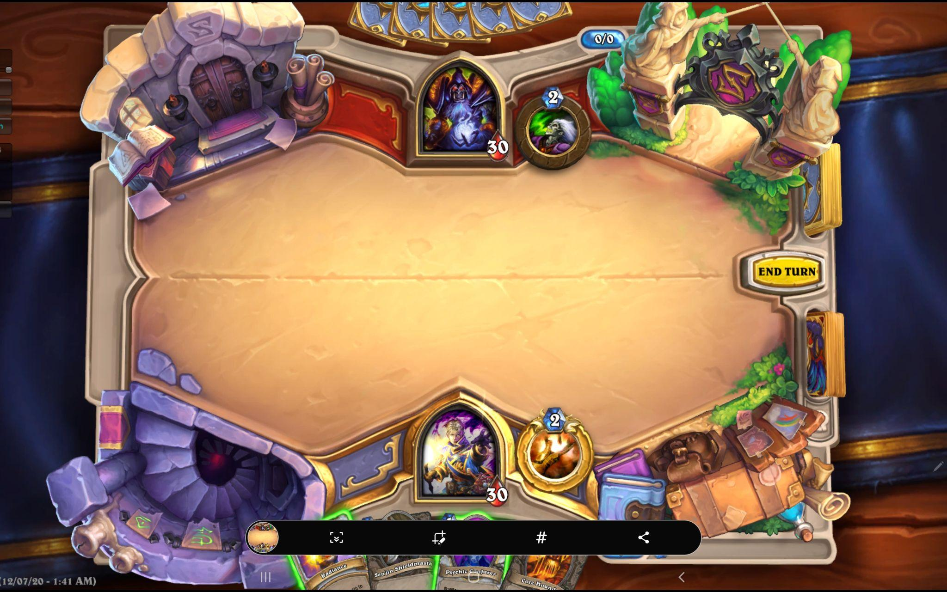

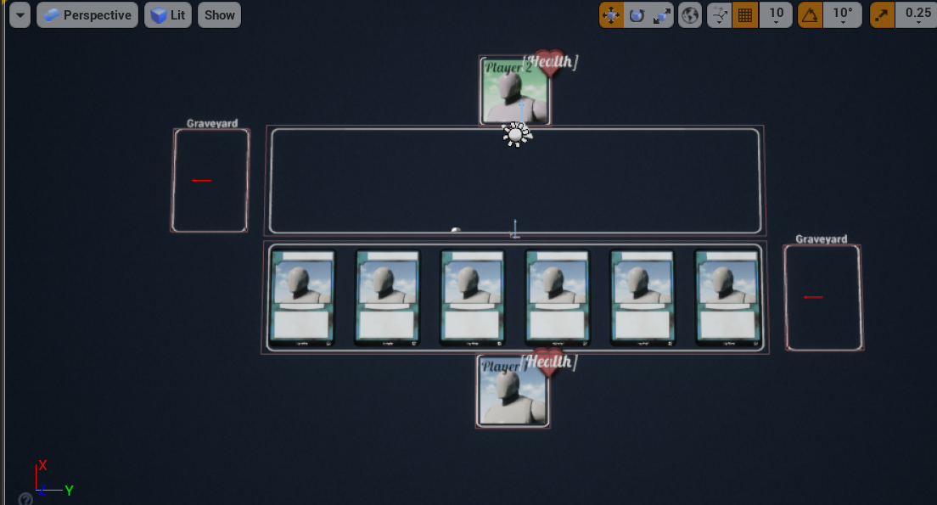

Card Decks

Overview

For the first deck (Heaven), The Paradiso (by Dante) will be represented by having different cards for the multiple spheres of Heaven while for the second deck (Hell), The Inferno (by Dante) will be represented by having different cards for the multiple circles of Hell.

Stats

1st Deck - Heaven | Stamina | Attack | Health | Abilities
Ethical Soul | 1 | 1 | 2 | Taunt
Ethical Soul | 1 | 1 | 2 | Taunt
Warriors of the Faith | 2 | 2 | 3 | No abilities
Warriors of the Faith | 2 | 2 | 3 | No abilities
Lovers | 3 | 2 | 3 | Deathrattle - Player gains 3HP
Lovers | 3 | 2 | 3 | Deathrattle - Player gains 3HP
Just Rulers | 3 | 3 | 3 | Taunt
Just Rulers | 3 | 3 | 3 | Taunt
Contemplatives | 4 | 3 | 4 | Summon last friendly creature that died
Contemplatives | 4 | 3 | 4 | Summon last friendly creature that died
Inconstant | 5 | 5 | 6 | No abilities
Ambitious | 5 | 4 | 5 | Taunt
Wise | 6 | 5 | 5 | No abilities
Fixed Stars | 6 | 6 | 6 | No abilities
Primum Mobile | 6 | 4 | 4 | Increases friendly minion attack by 2 (on played)
Warriors of Light | 7 | 7 | 7 | No abilities
Holy Grail | 8 | 5 | 10 | Player gains 5HP
God's Crown | 8 | 7 | 8 | No abilities
Heaven's Gate | 8 | 8 | 7 | Taunt
Heaven's Gate Keeper | 9 | 9 | 10 | Taunt
Magical Harp | 3 | / | / | 2 damage to all minions (friendly and enemy)
Magical Harp | 3 | / | / | 2 damage to all minions (friendly and enemy)
Adam's Rib | 3 | / | / | Player gains 5HP
Adam's Rib | 3 | / | / | Player gains 5HP
Adam's Rib | 3 | / | / | Player gains 5HP
Bliss | 5 | / | / | Deal 3 damage to enemy minions
Bliss | 5 | / | / | Deal 3 damage to enemy minions
The Blessed Pasture | 6 | / | / | Player gains 8HP
The Blessed Pasture | 6 | / | / | Player gains 8HP
Ark of the Covenant | 7 | / | / | Draw 4 Cards

2nd Deck - Hell | Stamina | Attack | Health | Abilities
Unfortunate Soul | 1 | 2 | 1 | Charge
Unfortunate Soul | 1 | 2 | 1 | Charge
Limbo | 1 | 2 | 2 | No abilities
Limbo | 1 | 2 | 2 | No abilities
Lust | 2 | 2 | 2 | Deathrattle - deals 2 damage to random enemy minion
Lust | 2 | 2 | 2 | Deathrattle - deals 2 damage to random enemy minion
Gluttony | 2 | 3 | 2 | No abilities
Gluttony | 2 | 3 | 2 | No abilities
Greed | 3 | 3 | 3 | Deathrattle - Draw 1 card
Greed | 3 | 3 | 3 | Deathrattle - Draw 1 card
Wrath | 3 | 2 | 3 | Taunt
Heresy | 3 | 6 | 3 | No abilities
Violence | 3 | 3 | 4 | When this card is dealt damage, it deals 1 damage to enemy minions
Fraud | 4 | 5 | 2 | Deathrattle, you might draw another, no matter now many cards you have in hand
Treachery | 4 | 4 | 2 | No abilities
Lord's Blessing | 4 | 2 | 5 | Charge
Medusa's Call | 5 | 6 | 4 | Deathrattle - deals 3 damage to enemy minions or player (enemy player takes damage is there are no enemy minions on the board)
Memory of Acre | 5 | 1 | 6 | Whenever this attack is damaged, deals 2 damage to enemy minions
Filippo's Rage | 6 | 3 | 2 | Clone itself 3x
Tristan's Desire | 7 | 9 | 8 | When it gets damaged, it deals 2 damage to the enemy player
Death's Blade | 2 | / | / | Destroy 1 minion (enemy) - 666 damage (random)
Death's Blade | 2 | / | / | Destroy 1 minion (enemy) - 666 damage (random)
Arrow of Paris | 5 | / | / | Increases friendly minions attack by 2 (all friendly minions)
Arrow of Paris | 5 | / | / | Increases friendly minions attack by 2 (all friendly minions)
Demon's Wing | 3 | / | / | Draw 2 cards
Coin of Plutus | 3 | / | / | Draws 4 cards, 1 less for each friendly minion
Coin of Plutus | 3 | / | / | Draws 4 cards, 1 less for each friendly minion
Frederick's Ring | 3 | / | / | Cause 4 damage to enemy player and 2 damage to you
Frederick's Ring | 3 | / | / | Cause 4 damage to enemy player and 2 damage to you
Calvalcanti's Blade | 4 | / | / | 5 Damage to enemy (player)

User Interface

Overview

For the interface, the game will have two health bars, a mana pool, two player profile pictures, two graveyards and a hand.

User Interface Detail #1

Each player will have a health bar, a mana pool, a profile picture, a graveyard and a hand where the player cards will be.

Multiplayer Game

Overview

Two players is the maximum number of players that can play at once. The game operates using a client server.

Play Instructions

Information about each deck/side

Heaven is our control deck with cards more focused on AoE attacks helping manage the amount of minions hell can place down hence controlling the board, heaven is based on the 9 spheres of heaven. Heaven takes advantage of Deathrattle cards which once the card is destroyed it restores HP to the player. Heaven has cards that once played allow the player to bring their last friendly creature back from the graveyard; there are also cards that increase the attack dmg of cards. Heaven is all about survival.

Hell is our aggro deck with cards focused on dealing dmg to a single target and to try to overpower the opposite team, Hell is all about placing as many cards down (max of 7 cards on the board) trying to overwhelm heaven. Hell is based on the 9 circles of Hell. Hell takes advantage of Deathrattle cards but they work differently compared to the Heaven ones. For example Hell has a card that once destroyed deals dmg to all enemy minions it also has another card that once destroyed the player is allowed to draw another card to replace it.

Player Side

Player one must choose the Heaven deck and player two the Hell deck. So if you want to play as Heaven you will have to select to play as player one and if you would like to play as Hell you will have to select player two.

Keywords

Hand - cards held by the player.
Taunt - minion that must be attacked and removed before the player can be attacked.
Deathrattle - ability where the stated effect occurs when the minion or weapon is destroyed.
Charge - a minion that can attack during the same turn it's put in play.

Reference List

Music In-Game

Kyle Lovett Warfare & Worship Music (2020) Lion Of Judah / Prophetic Warfare Music. Available at: https://www.youtube.com/watch?v=7Exv-7kFk4U (Accessed: 3 February 2022).

Kyle Lovett Warfare & Worship Music (2019) SOUNDS FROM HEAVEN - 1 HOUR INSTRUMENTAL. Available at: https://www.youtube.com/watch?v=leae2cEi4xw (Accessed: 3 February 2022).

Board Design

Epic Games (2015) Infinity Blade: Fire Lands. Available at: https://www.unrealengine.com/marketplace/en-US/product/infinity-blade-fire-lands (Accessed: 2 February 2022).

Epic Games (2015) Infinity Blade: Grass Lands. Available at: https://www.unrealengine.com/marketplace/en-US/product/infinity-blade-plain-lands (Accessed: 2 February 2022).

‌tharlevfx (2016) Water Materials in Materials. Available at: https://www.unrealengine.com/marketplace/en-US/product/water-materials (Accessed: 2 February 2022).

Pack Dev (2021) Mountains & Meadows. Available at: https://www.unrealengine.com/marketplace/en-US/product/mountains-meadows-i-outdoor-environment (Accessed: 2 February 2022).

Cards Design

‌
Fred Taylor (2021) Stylized Shield. Available at: https://www.artstation.com/artwork/YeEG56 (Accessed: 30 January 2022).

intheintrestoftime (2005) rib cage and pelvis study. Available at: https://www.deviantart.com/intheintrestoftime/art/rib-cage-and-pelvis-study-14660024 (Accessed: 29 January 2022).

Julia Stumpe (2019) Overgrown Cemetery. Available at: https://www.artstation.com/artwork/e0V4y3 (Accessed: 29 January 2022).

Nancy Riggle (no date) Backstab. Available at: https://www.pinterest.pt/pin/315181673897248257/ (Accessed: 29 January 2022).

Dylan Matias (2021) El infierno. Available at: https://www.pinterest.pt/pin/993888211486349380/ (Accessed: 29 January 2022).

Julie Beliveau (2020) Dragon Swords. Available at: https://www.artstation.com/artwork/qAE1gz (Accessed: 28 January 2022).
Christoffer Ryrvall (2020) Ring. Available at: https://www.artstation.com/artwork/oO1XBz (Accessed: 28 January 2022).

Oliver Schümann (2016) Ancient Coins. Available at: https://www.artstation.com/artwork/YJRG3 (Accessed: 28 January 2022).

Oliver Schümann (2021) Demon wing tattoo design. Available at: https://www.artstation.com/artwork/YJRG3 (Accessed: 28 January 2022).

Mirko Failoni (2017) 4/365 Mystic Arrow. Available at: https://www.artstation.com/artwork/oBxVJ (Accessed: 28 January 2022).

Jason Chan (no date) Iona, Shield of Emeria, MTGNexus. Available at: https://www.mtgnexus.com/gallery/art/1879-iona-shield-of-emeria (Accessed: 28 January 2022).

Konstantin Vavilov (2018) Day 6: Trusty SWORD. Available at: https://www.artstation.com/artwork/8GWWQ (Accessed: 28 January 2022).

Angel Motivation (2021) SPIRITUAL WARFARE | Put on the Armor of God - Inspirational & Motivational Video Available at: http://believ.tv/@angelmotivation (Accessed: 28 January 2022).

Nexumorphic (2021) Awakening. Available at: https://www.artstation.com/artwork/xJN2QW (Accessed: 28 January 2022).

Elemental Beings Online Shop | Elemental Beings (2021) Seraphim Angel Soul Healing Full Moon Workshop. Available at: https://www.elementalbeings.co.uk/crystal-shop/Seraphim-Angel-Soul-Healing-Full-Moon-Workshop-p393026077 (Accessed: 28 January 2022).

Joseph Meehan (2016) Blood Mist. Available at: https://www.artstation.com/artwork/r2KVm (Accessed: 28 January 2022).

Christianity.com (2019) What Was the Ark of the Covenant? Its Meaning and Significance. Available at: https://www.christianity.com/wiki/bible/what-was-the-ark-of-the-covenant-its-meaning-and-significance.html (Accessed: 28 January 2022).

banihilman (2013) High Up. Available at: https://www.deviantart.com/banihilman/art/High-Up-377712576 (Accessed: 28 January 2022).

Stefan Kopinski (2017) Medusa. Available at: https://www.artstation.com/artwork/gyg0m (Accessed: 28 January 2022).

Desktop Nexus Wallpapers (2011) HAPPY ANGEL. Available at: https://abstract.desktopnexus.com/wallpaper/731599/ (Accessed: 28 January 2022).

Deviantart (no date) Magical Harp. Available at: https://www.pinterest.co.uk/pin/288441551104818010/ (Accessed: 28 January 2022).

Unstable Anomaly (2020) Blessing. Available at: https://www.artstation.com/artwork/RY4grE (Accessed: 28 January 2022).

Diablo Wiki (no date) Tyrael. Available at: https://diablo.fandom.com/wiki/Tyrael (Accessed: 28 January 2022).

www.istockphoto.com (no date) Gates Of Heaven Stock Photos, Pictures & Royalty. Available at: https://www.istockphoto.com/photo/theres-a-light-at-the-end-of-the-stairway-gm502859687-44381116 (Accessed: 28 January 2022).

Crosswalk.com (2019) Why Should We Earn Crowns for Heaven?. Available at: https://www.crosswalk.com/church/pastors-or-leadership/ask-roger/why-should-we-earn-crowns-for-heaven.html (Accessed: 28 January 2022).

‌Charney, N. (2017) What you don’t know about the Holy Grail, Salon. Available at: https://www.salon.com/2017/04/23/what-you-do-not-know-about-the-holy-grail/ (Accessed: 28 January 2022).

Posterazzi (2022) Illustration For Paradiso By Dante Alighieri Canto Xxxi Lines 1 To 3 By Gustave Dore 1832-1883 French Artist And Illustrator. Available at: https://www.posterazzi.com/illustration-for-paradiso-by-dante-alighieri-canto-xxxi-lines-1-to-3-by-gustave-dore-1832-1883-french-artist-and-illustrator-posterprint-item-vardpi1857094/ (Accessed: 28 January 2022).

Jeffrey Smith (2016) The Narcissist. Available at: https://www.artstation.com/artwork/8komq (Accessed: 28 January 2022).

Partridge, J. (2016) Fixed Star Alcyone, Astrology King. Available at: https://astrologyking.com/alcyone-star-pleiades/ (Accessed: 28 January 2022).

EckoKnight (no date) White Angel. Available at: https://br.pinterest.com/pin/510947520196755386/?amp_client_id=CLIENT_ID(_)&mweb_unauth_id=%7B%7Bdefault.session%7D%7D&simplified=true (Accessed: 28 January 2022).

Gordana K. (no date) .**. . Available at: https://www.pinterest.co.uk/pin/392024342536435361/ (Accessed: 28 January 2022).

Diablo Wiki (no date) Imperius. Available at: https://diablo-archive.fandom.com/wiki/Imperius#:~:text=Archangel%20Imperius%2C%20The%20Aspect%20of (Accessed: 28 January 2022).

WallpaperAccess (no date) Awesome Angel Love Wallpapers. Available at: https://wallpaperaccess.com/angel-love (Accessed: 28 January 2022).

mike franchina (2021) Heresiarch. Available at: https://www.artstation.com/artwork/ZGgKRm (Accessed: 28 January 2022).

Wallpaper Flare (no date) HD wallpaper: Fantasy, Angel Warrior, Wings, Woman. Available at: https://www.wallpaperflare.com/fantasy-angel-warrior-wings-woman-wallpaper-giijj (Accessed: 28 January 2022).

Taran Fiddler (2019) Inktober 2019!. Available at: https://www.artstation.com/artwork/RYd0VW (Accessed: 28 January 2022).

Sarah Morris (2021) Greeds Folly. Available at: https://www.artstation.com/artwork/zOyR6Q (Accessed: 28 January 2022).
Thomas Lue (2021) Glutton. Available at: https://www.artstation.com/artwork/eamGr3 (Accessed: 28 January 2022).

Austen Mengler (2015) STEM. Available at: https://www.artstation.com/artwork/aYdqR (Accessed: 16 November 2021).

Austen Mengler (2013) Miasma. Available at: https://www.artstation.com/artwork/rAPNJ (Accessed: 16 November 2021).

UselessHopeless (2012) Dark Souls Hollow. Available at: https://www.deviantart.com/uselesshopeless/art/Dark-Souls-Hollow-339462012 (Accessed: 16 November 2021).

